NT5 Pauline III: 1 & 2 Thessalonians, Pastorals, Philemon
Dr. Marvin J. Effa
1 Thessalonians
Author: Paul wrote 1 Thessalonians, as stated in 1:1. Although others are listed in 1:1, Paul uses the first person when writing the letter, cf. 4:13.
Date of writing: Early Summer, 51.
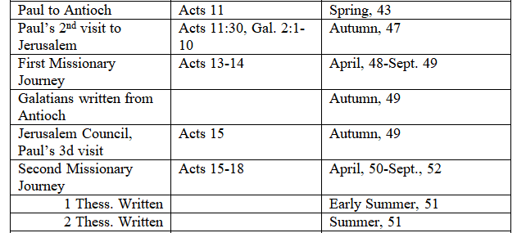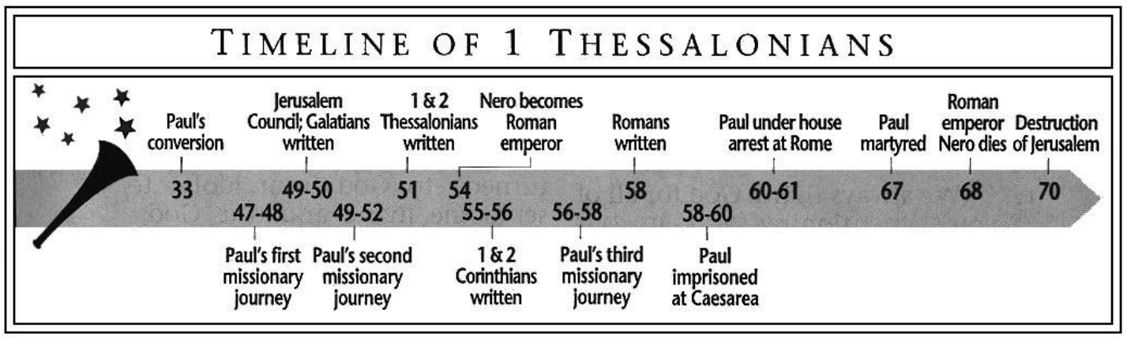
Purpose: Having defended his ministry, Paul writes to direct the readers to moral purity, confidence in the believer’s rapture or resurrection, and specific problems in the church.
Idea: The gospel that brings persecution also sanctifies us and delivers us from the coming wrath.
Development:
1 Thessalonians: The gospel that brings persecution also sanctifies us and delivers us from the coming wrath.
Introduction: Grace and peace to the church of God! 1 Thessalonians 1:1-2
- They received the gospel with assurance, joy, persecution, and promise. 1 Thessalonians 1:3-10.
- The apostolic team modeled the worthy-walk of the gospel. 1 Thessalonians 2:1-12.
- Welcoming the word of God resulted in severe persecution. 1 Thessalonians 2:13-20.
- Paul’s concern for them was resolved by Timothy’s visit: they have faith and love! 1 Thessalonians 3:1-13.
- In light of Christ’s coming (3:13), please God by:
  - Keeping the apostolic commandments, 1 Thessalonians 4:1-2.
  - Abstaining from sexual immorality, 1 Thessalonians 4:3-8.
  - Loving one another, 1 Thessalonians 4:9-10.
  - Working hard at your own business, 1 Thessalonians 4:11-12.
- Comfort one another with the truth of Christ’s imminent return, 1 Thessalonians 4:13-18.
- Comfort one another with the truth that we are not appointed to wrath, 1 Thessalonians 5:1-11.
- While suffering, function as the body of Christ, 1 Thessalonians 5:12-22.
Conclusion: The God of grace and peace will preserve you, 1 Thessalonians 5:23-28.
Key Passage Exegesis
- Some believers will not die, but will be caught up to meet the Lord, 1 Thessalonians 4:13-18.
- Christians will not go through the Tribulation, 1 Thessalonians 5:1-11.

2 Thessalonians
Author: Paul wrote 2 Thessalonians, as stated in 1:1. Although others are listed in 1:1, Paul uses the first person when writing the letter, cf. 3:17.
Date of writing: Late in the summer of 51. See above for charts and dates.
Purpose: To correct misunderstandings about persecution, the Tribulation, and poor work ethics.
Idea: Prophecy brings comfort not fear.
Development:
2 Thessalonians: The Tribulation is fitting judgment on those who trouble the church, so get to work.
- The Tribulation is a proper penalty for the world persecuting the church, 2 Thessalonians 1.
- False teachers fail to recognize the difference between trouble and the Tribulation. Christians are not, nor ever will be, in the Tribulation, 2 Thessalonians 2.
- Difficulties and false teachers are no excuse for personal irresponsibility: Deal with it! 2 Thessalonians 3.
Key Passage Exegesis
- Christians are not in the Tribulation, 2 Thessalonians 2.
- Lazy believers should experience church discipline, 2 Thessalonians 3.

1 Timothy
Author: Paul states that he is the author in 1 Timothy 1:1.
Date of writing: Some of Paul’s letters were written after the close of Acts and information must be stitched together from other epistles. Paul was headed into Macedonia, but left Timothy in Ephesus. He functioned as the pastor of the church. Dates range from 62 – 66 AD. 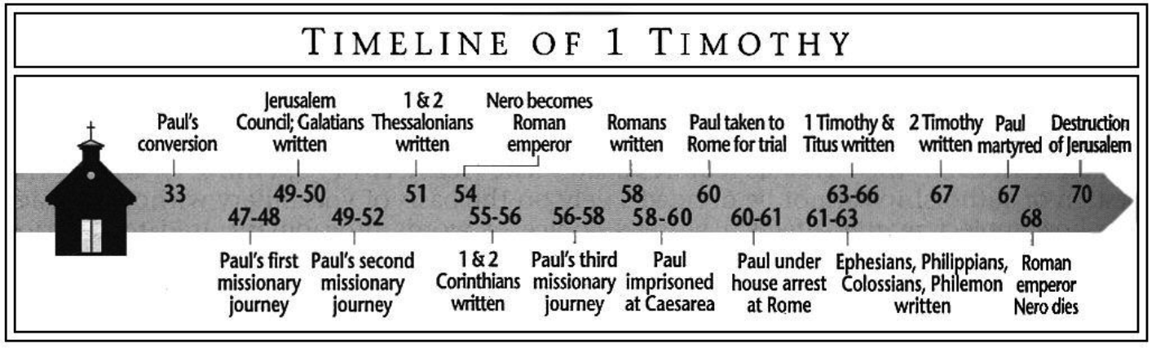
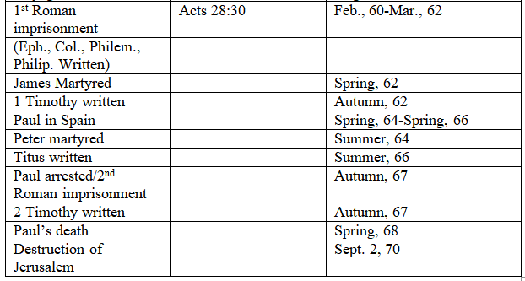
Purpose: To provide written instructions to Timothy should Paul’s return to Ephesus be delayed.
Idea: God’s household must follow sound doctrine that produces godliness.
Development:
1 Timothy: God’s household must follow sound doctrine that produces godliness.
- Pastors must only allow sound doctrine, 1 Timothy 1-4.
- Sound doctrine transforms the households, 1 Timothy 5-6.
Key Passage Exegesis
- Jesus is the substitutionary ransom for the whole world, 1 Timothy 2.
- Bishops and deacons must preside well over their households, 1Timothy 3.
- Only qualified widows should receive money from the church, 1 Timothy 5.

2 Timothy
Author: Paul states that he is the author in 2 Timothy 1:1.
Date of writing: As Paul’s final letter this was written shortly before his death in the fall of 67 or spring of 68.
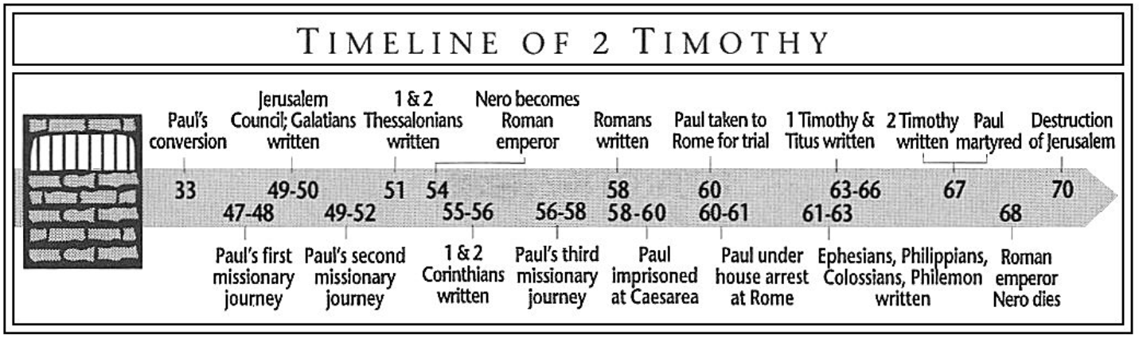
Purpose: To encourage Timothy to come visit him in Rome before his execution.
Idea: Believers should fulfill their ministry regardless of the opposition.
Development:
2 Timothy: Pastors should embrace the suffering attached to the gospel because the Lord will reward those who boldly hold fast during suffering, shame, and apostasy.
- Be strong and suffer for the gospel, 2 Timothy 1-2:13
- Endurance will be rewarded, so correct the ungodly believers, 2 Timothy 2:14-3:9.
- Keep preaching the word, for the Lord will deliver us into His kingdom, 2 Timothy 3:10-4:22.
Key Passage Exegesis
- A trustworthy statement, 2 Timothy 2:11-13.
- Preach the gospel in every environment, 2 Timothy 4:1-4.

Titus
Author: Paul wrote this letter, Titus 1:1.
Date of writing: Dates range from 62-66 AD.
Purpose: To help Titus transform a party island into a New Testament church.
Idea: God’s grace leads to godliness, not dissipation.
Development:
Titus: Leaders must stop the cultural bias of laziness and replace it with Spirit-empowered, grace-based good works.
- Good leaders stop bad teachers, Titus 1.
- While waiting for Christ’s return, authoritatively teach the household responsibilities, Titus 2.
- Justification by grace should lead to good works, Titus 3.
Key Passage Exegesis
- God’s grace teaches godliness and an anticipation of Christ’s return, Titus 2:11-15.

Philemon
Author: Paul wrote Philemon, as stated in 1:1. Although others are listed in 1:1, Paul uses the first person when writing the letter, cf. 1:4.
Date of writing: Philemon was written during Paul’s first Roman imprisonment.
Purpose: To persuade Philemon to forgive Onesimus’s crimes.
Idea: One’s legal standing before God does not automatically absolve one’s human responsibilities.
Development:
Philemon: Philemon should receive Onesimus as if he were Paul himself.
- As one of the Lord’s leaders, accept Onesimus back as if he were Paul; Paul will pay his debt, if necessary, 1.
Numerical occurrences of virtues in Paul's letters  knowledge 210  Faith/faithfulness 165  goodness 118  love 117  righteousness 74  holiness 64  peace 49  truth 49  obedient 32  mercy 28  joy 23  confidence 21  exhortation 19  boldness 17  purity/pure heart 14  kindness 13  patience 13  zealous 13  diligence 12  gentleness 11  longsuffering 10  submission 9  soberly 8  steadfastness 8  reverence 7  generous 6  order, good 6  self-control 6  humility 5  lowliness 5  liberality 4  quietness 3  cheerfulness 2  fervent 2  meekness 2 | Household Passages:  1 Corinthians 7:1-9  1 Corinthians 11:2-16  1 Corinthians 14:33b-38  Galatians 3:26-29  Ephesians 5:22-33  Ephesians 6:1-4  Colossians 3:18-4:1  1 Timothy 2:8-15  1 Timothy 5:3-16  Titus 2:1-6  Hebrews 13:4  1 Peter 3:1-7

